Hello,

This guide will show you how to manage KoFrMa AdminApp and plan tasks for daemons. If you don’t have our software installed, check the install guide instead.

1. Login to the KoFrMa AdminApp with default credentials that were given to you with the license when you ordered it.

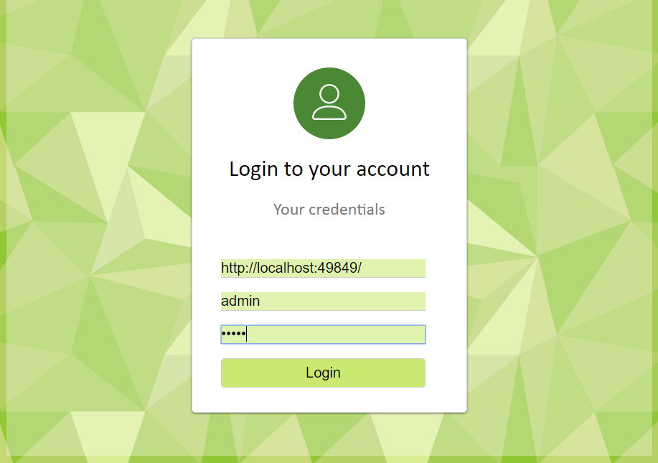

1. Navigate to table Admin Accounts and click on Add Administrator

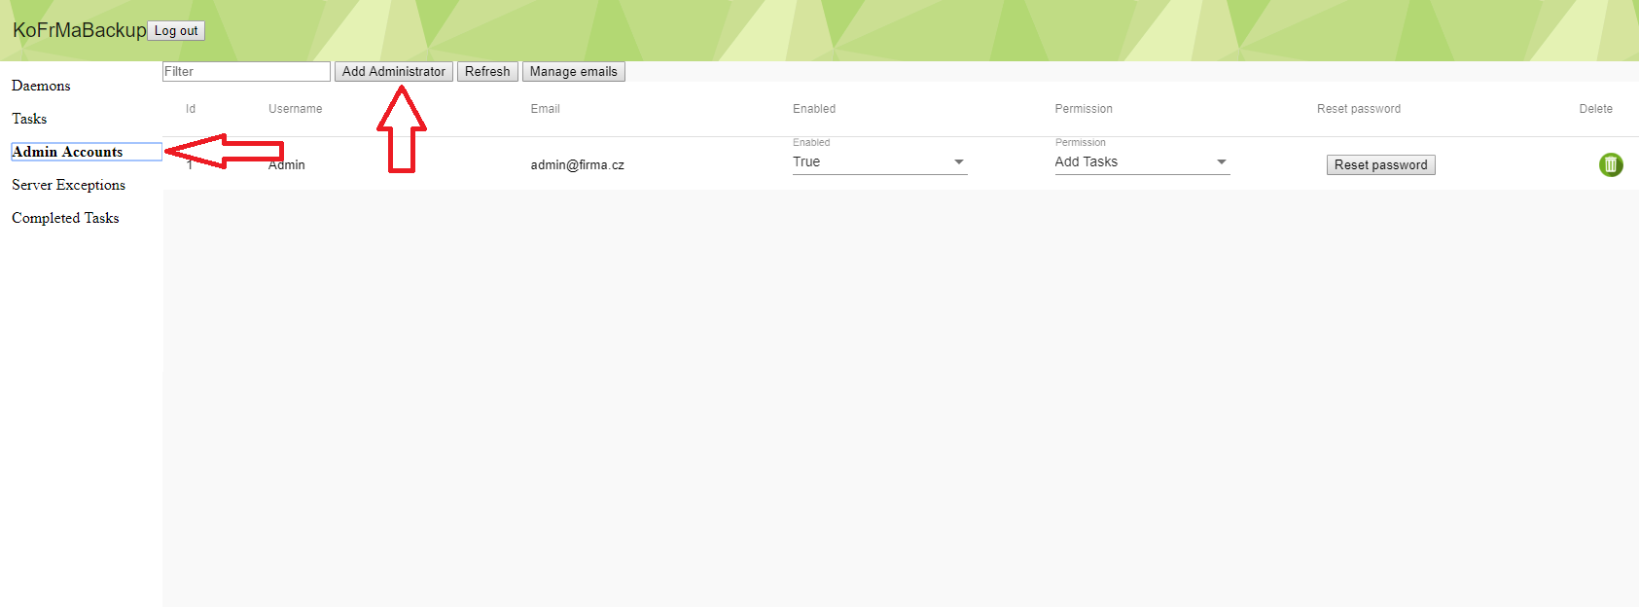

1. Enter credential for new administrator and add him permissions.

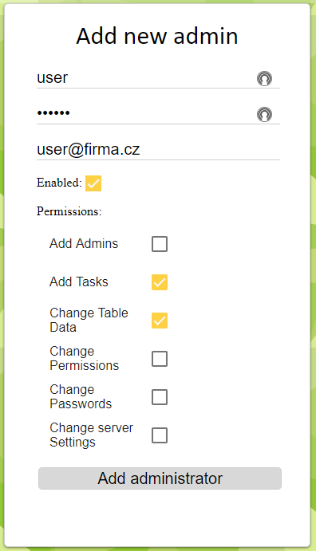

1. (Optional) Delete default Admin account for higher security

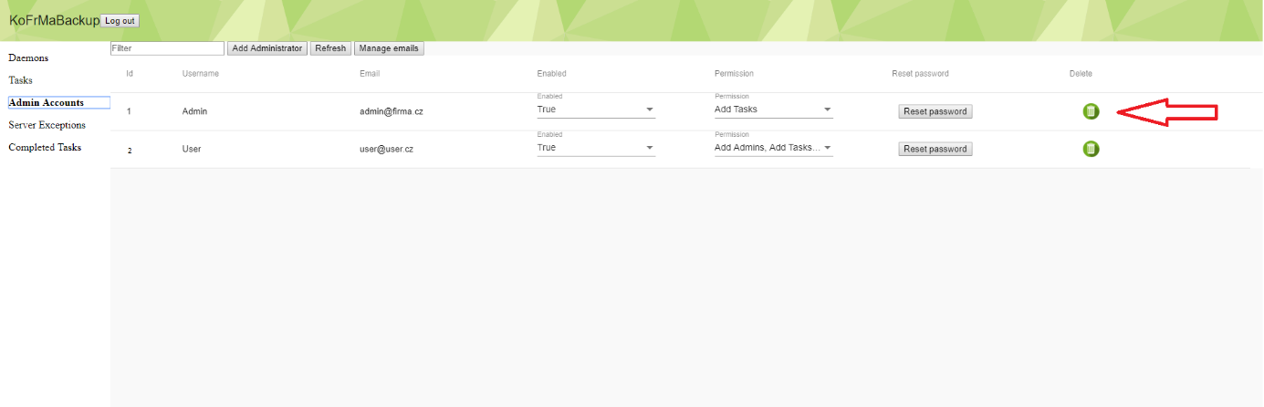

1. Navigate to table Daemons, if you have already installed your first daemon, it should show up here. Click on More Info to customize daemon‘s behaviour.

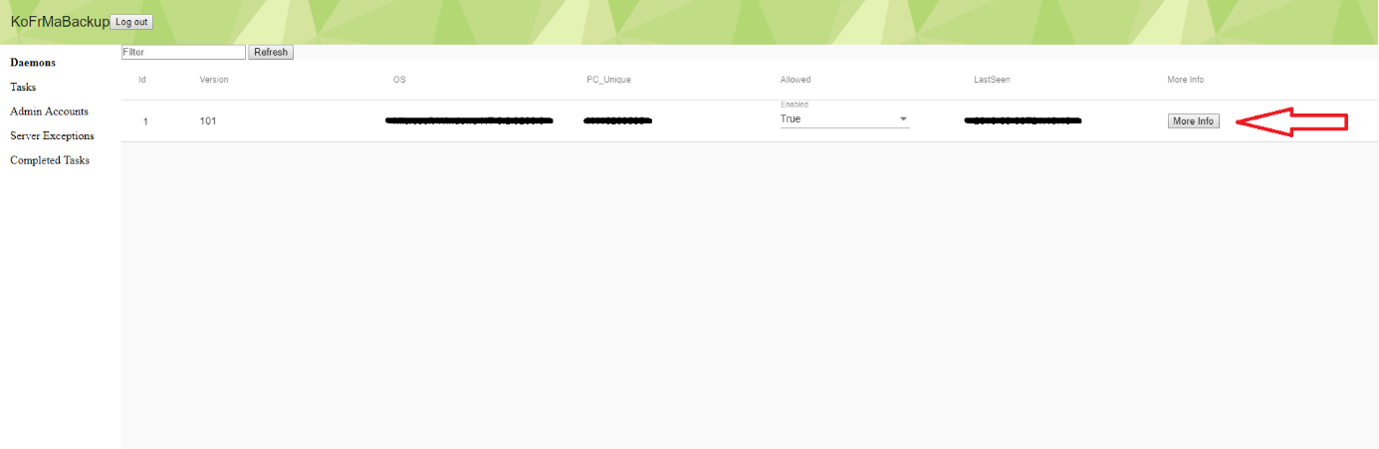

1. Here you can set how often will the daemon check for tasks:
   * *Timer Tick* defines how often will the daemon check for new tasks under normal conditions. Recommended value is around 1 hour, depending on your backuping plan.
   * *Retry after failed connection* sets the time period after daemon will try to reconnect if previous connection failed. Recommended value is around 5 minutes.
   * *After start* sets the delay of daemon after the service (computer) starts. Recommended value is 1 second, if you have any specific needs you can change it but otherwise use the recommended value.

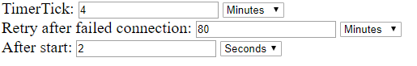

1. Click on Add Task if you want to plan new task for this daemon

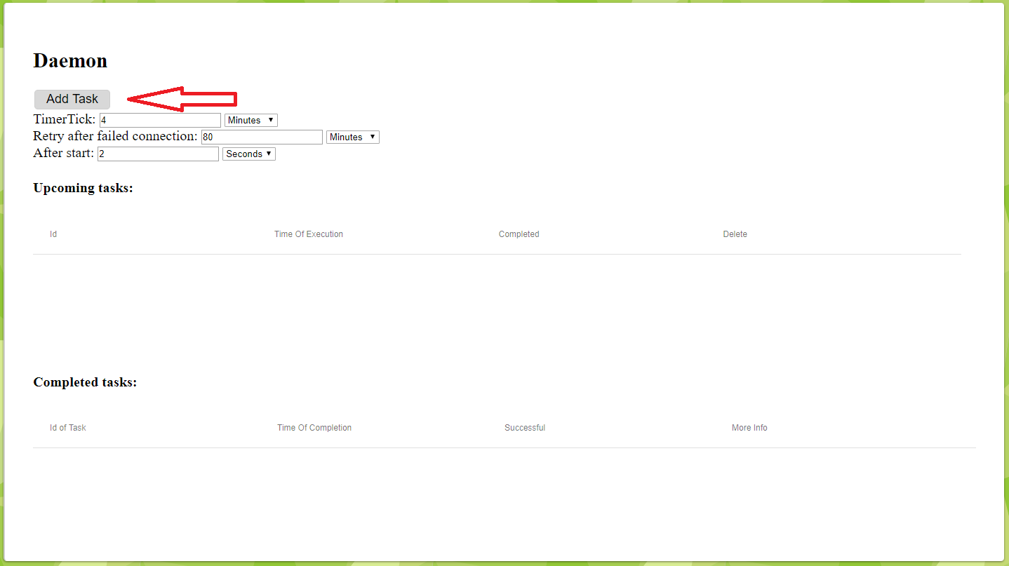

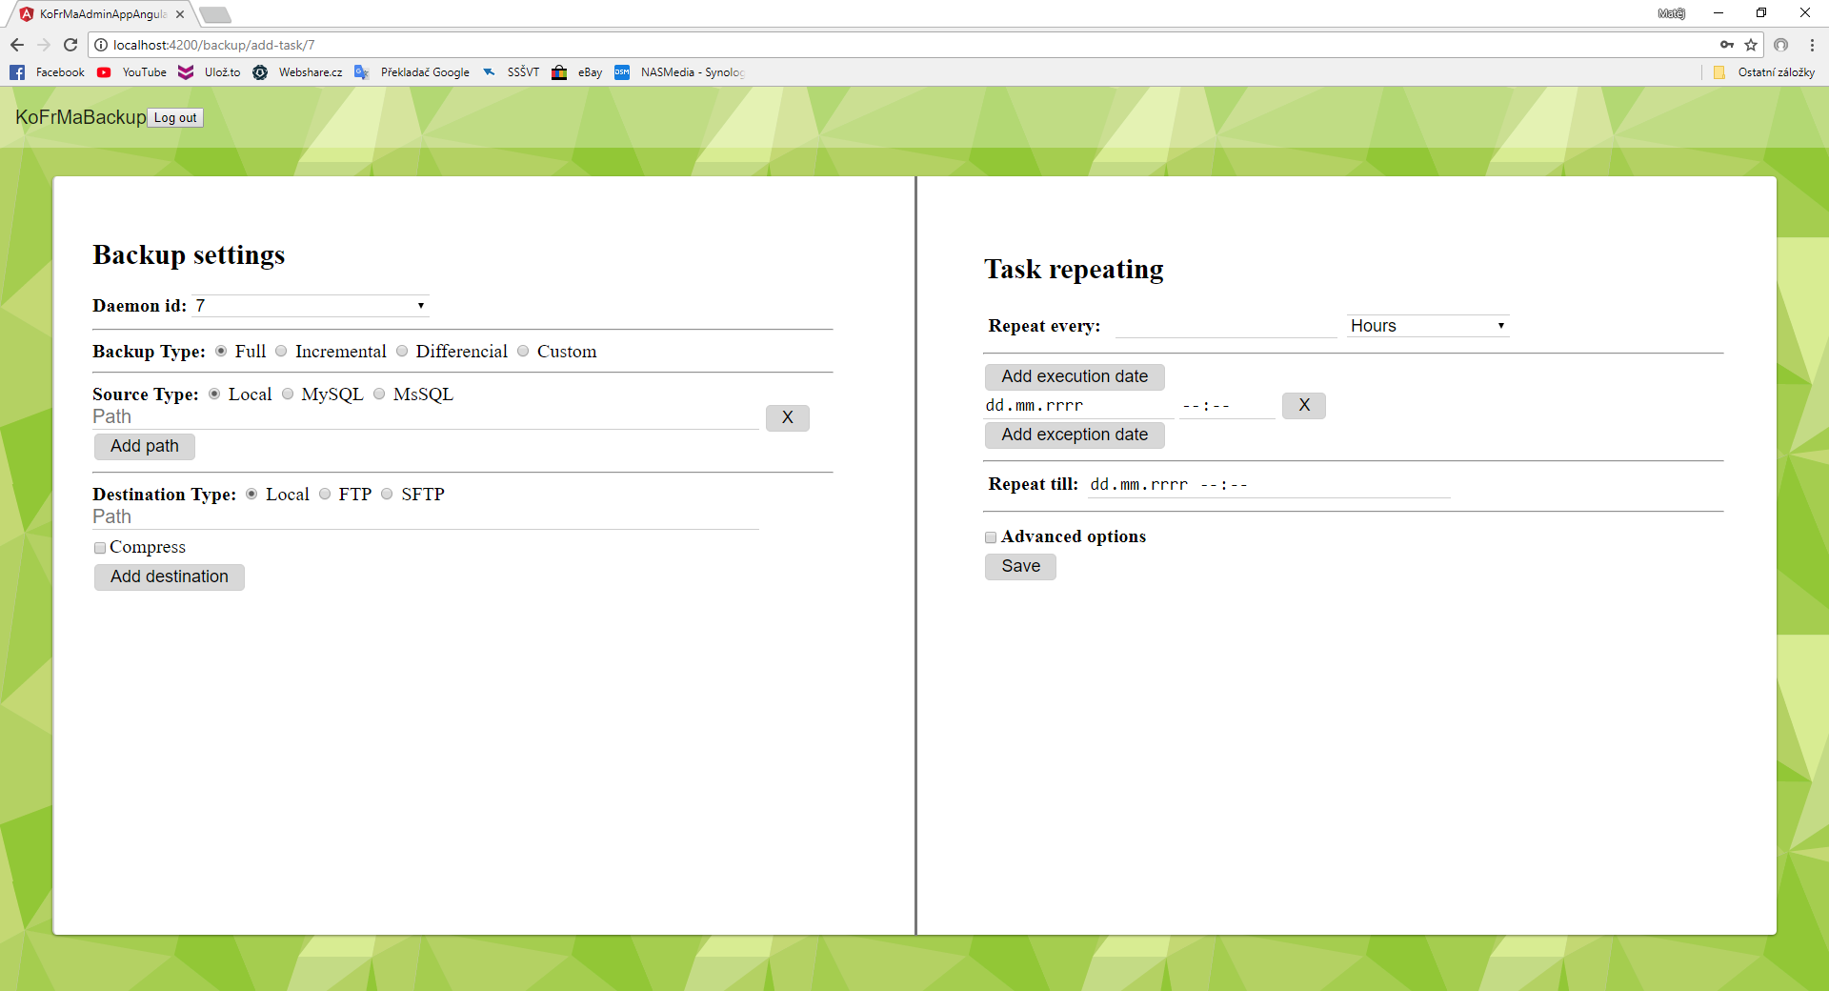

1. Set desired type of the task



* + Full backup creates exact copy of source folder but uses more space because everything is backed up even files that weren’t changed. This method is probably the one you are looking for if you want to do *one-time backup*.
  + Differential backup builds on older full backup and it backs up only new or changed files since the full backup. Note that you MUST have Full backup first that you want to build on. It makes more sense if differential backup is used on repeating tasks. If you select this mode and you don’t have any full backup that you want to base on, you will need to select to do a full backup first. In the Full backup after every field, you enter how many differential backups will be made before one full backup will be made. This option works only if you are doing repeating task.



* + Incremental backup builds on every type of older backup (even other incremental) and it backs up only files that were changed since then. It is the most efficient backup in terms of space, but it offers less redundancy because one lost backup means that it can’t be restored. Like with the differential backup, you MUST have differential or incremental backup first that you want to build on. It makes much more sense to use it on repeating tasks. If you select this mode and you don’t have any older backup that you want to base on, you will need to select to do a full backup first. In the *Full backup after every* field, you enter how many incremental backups will be made before one full backup will be made. This option works only if you are doing repeating task.



* + Custom backup is very advanced so continue if you know how types of backups works and you know what you are doing. Here you can set the order of backups that would be repeated over and over. For example, if you want to make Full backup first, then Differential and then Incremental, you can write 021. After the incremental will be completed it will do again full, differential, incremental and so on. This mode works only if you select that you want to repeat the task.



1. Add sources that will be backed up. KoFrMa Daemon can backup either folder(s) or databases:
   * If you want to backup folder, select *Local* and then enter folders that you want to back up. Click on *Add path* to add another folder that would be backed up, there is no limit of them.

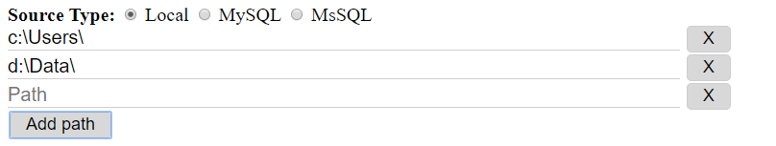

* + If you want to backup up database, select type of your database (MySQL/MSSQL) and enter server address, database name and credentials. Note that the database user must have permissions to backup, or backup will fail.

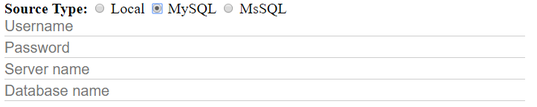

1. Enter destination(s) of your backup. You may backup to local drive or chose one of the remote protocols.
   * Local destination points to local disk (in daemon PC) or it can be shared folder that daemon must have access to.
   * FTP or SFTP protocols needs server address with folder and require credentials (with permission to write) to access it.
   * You can add more destinations and every one of them can be on different media and can be archive or not. The daemon will automatically choose the best destination in terms of speed and then copies the backup to the others.
2. If you want to make archive of your backup, select the *Compress* checkbox and set the format and compression ratio. Note that you must have set paths to WinRAR or 7Zip on daemon computer if you want to make .rar or .7z format. If you want to split output files in chunks (for ex. for easier upload), you can enter number of MiB that the file will be split.

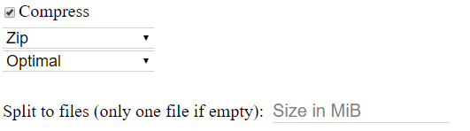

1. If you want to repeat this task, enter information about repeating plan. Otherwise, fill in only *Execution date*.
   * Enter number of time units after the task will be repeated



* + Enter first day and time of execution, or enter more of them, if you for example want to backup every Monday and Wednesday, set *Repeat every* to 1 week and then add two execution dates, one on nearest Monday and one on Wednesday

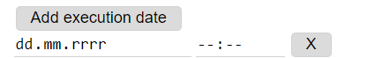

* + If you want to skip some particular days, you can manually select them



* + If the repetition should end someday, enter the day in *Repeat till*



1. (Optional) if you want to edit more advanced backup features, check this box

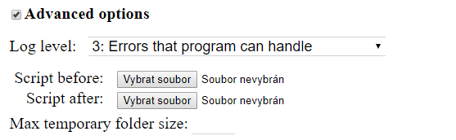

* + Here you can specify what level of log will the daemon make, if you want to troubleshoot, raise the value. You can later view this log on admin app and it is received in emails.



* + If you want the daemon to perform specific actions before and after the backup, you can upload, write or enter path to the script in .bat, .ps1 or .vbs

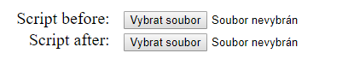

* + If the backup destination is only remote, daemon will create temporary folder in c:\Windows\Temp\ and deletes it after the backup. If you want to limit the size of the temp folder (for ex. little space on drive C) you can enter the value in MBs. Leave it blank for no limit.



1. After the daemon completes the task, navigate to the completed task section and click on *More Info* at the task you want to learn the details about.

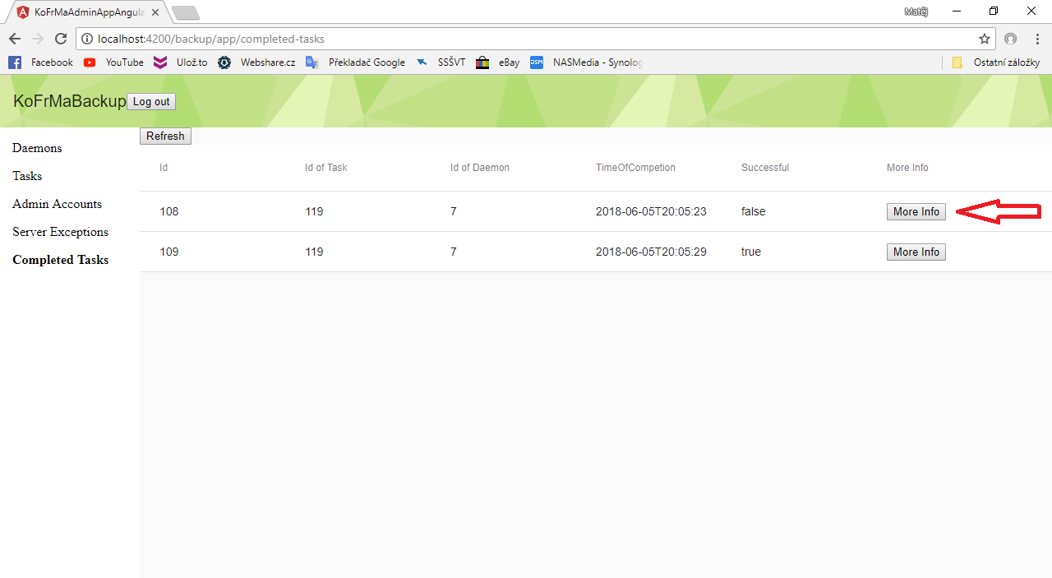

1. If you want to receive email reports, navigate to *Admin Accounts* table and click on *Manage emails*.

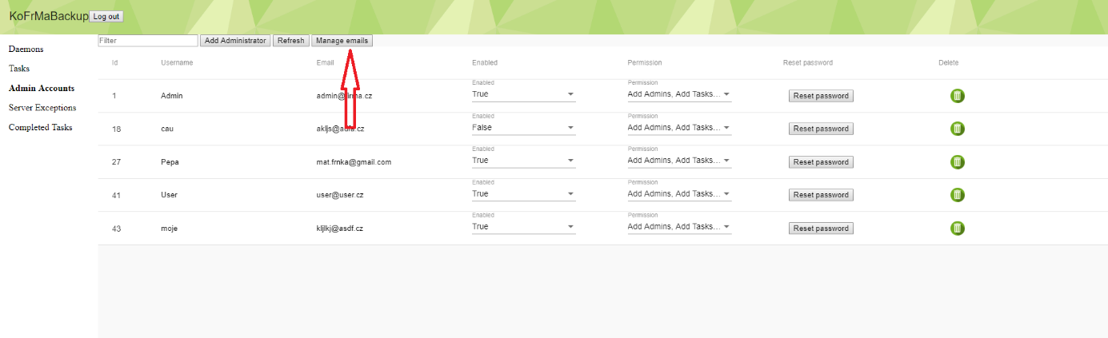

* + Set the email plan similarly to backup plan at point 12). to receive emails with reports to your email.

